Chapter 1

## Implementation

### Chapter Overview

This chapter describes in detail how the proposed system was implemented. Similarly, the selected technologies for each component, and the reasons for their selection, as well as how the backend, frontend and data science components were implemented, and the structure of the proposed system Such things Discussed in detail in this section.

### Overview of the prototype

### Basic flow of the system

* If the user is new to the application, he will register and log in to the app.
* Or the user can use the application by clicking on the guest button,
* The user then selects the skin color using image processing or a slider.
* Once selected, the application will ask some questions (allergies related questions) from the user.
* Make-up products and tips will be suggested based on his answers.

### Technology selections

When considering selected technologies, Each technology was selected by the team after several researches, for example, although many technologies (MongoDB, MySql and Firebase) could be applied to the database section, after much research the appropriate database technology was selected for our proposed system. Similarly, optimal technologies for image processing and frontend components were selected

|  |  |  |
| --- | --- | --- |
| **Component** | **Technologies Used** | **Reason for selection** |
| Frontend | * Flutter | * Reduced Code Development Time * Increased Time-to-Market Speed * Similar to Native App Performance * Custom, Animated UI of Any Complexity Available * Own Rendering Engine |
| Image processing | opencv | * Low RAM usage * OpenCV is available free of cost |
| Database | Firebase | * Faster time to market * Reduces development time and effort * Real-Time Database Scalability * Google Analytics Integration * Flexible Cost |

### Implementation of the data science component.

### Implementation of the backend component

### Implementation of the frontend component

Users will evaluate a mobile application by its front end, and if the frontend structure is not beautiful, the rate at which people use the application will decrease. So the way people use an application will be judged by the frontend of that application. The proposed system was designed as a frontend using the Flutter framework after much research.

Added text fields buttons and validations to the authentication area. For example, the following code was used for the button and validation.

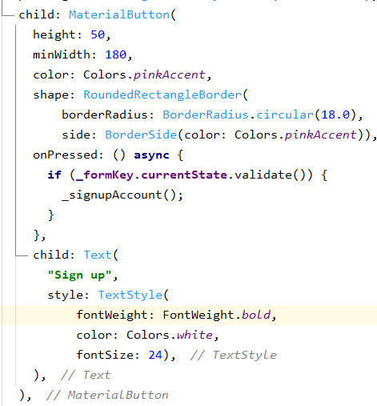

And the following code for the text field

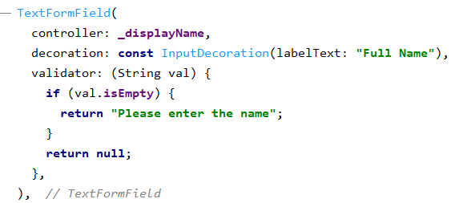

Using these codes, the text field, validation and buttons of the application will be displayed as follows.

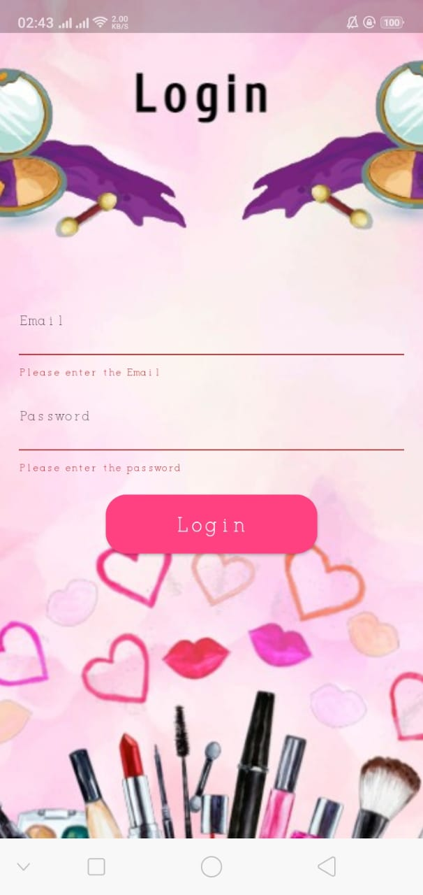

### Deployments/CI-CD Pipeline